Dovercourt Sidewalk and Bike Lanes

Dovercourt Sidewalk (south)
On-Line Consultation and Survey

The City of Ottawa invites you to an opportunity to provide your input to the planned sidewalk on Dovercourt Avenue from Broadview Avenue to Churchill Avenue plus bike lanes from Sherbourne Avenue to Churchill Avenue. For details and to provide comments via an online survey please visit Ottawa.ca/dovercourtavenue
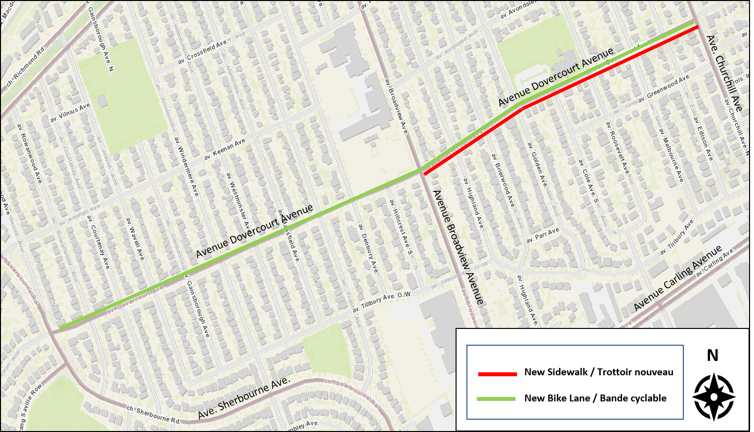

What: - This is a planned project from the Council-approved 2013 Ottawa Pedestrian Plan.
- As a collector road, policy states that Dovercourt Avenue should have a pedestrian facility on both sides.
- Dovercourt Avenue is designated a Neighbourhood Bikeway in the 2013 Ottawa Cycling Plan.
- The sidewalk and reserved bike lanes will be installed within the City’s right-of-way.
- Curbside bike lanes require removal of on-street stopping and parking except for transit vehicles.
- Landscaping and other features within this right-of-way may be impacted; however, the intent is to place the sidewalk to minimize the impact on existing trees.

Why: - Providing a sidewalk on the south side of Dovercourt Avenue will improve access to transit stops.
- It will provide a more user-friendly facility for all pedestrians including children, wheelchair users and persons with visual impairments.
-The additional sidewalk will encourage fewer midblock crossings.
- Bike lanes improve user comfort and safety by providing dedicated road space without requiring the need to share space with moving or parked motor vehicles.
- Sidewalk and bike lane requirements are of increasing importance when a corridor provides access to schools and community facilities and is a public transit route.

When: - Currently, the project is in the planning stage.
- Following planning, detailed design will begin and a timeframe for construction will be determined.
- Project will be discussed at a Zoom webinar meeting sponsored by Councillor Leiper on Thursday, April 8, 2021 at 7:00 pm. The web address is https://us02web.zoom.us/j/83595231833 and the password is 766804. The webinar ID number is 835 9523 1833.

Input may be provided either on the project website, during Councillor Leiper’s webinar or you may also provide comments in writing to the City’s project manager, listed below. Accessible formats and communication supports are available, upon request.

For more information please contact:
Robin Bennett, Project Manager, Cycling Programs;
Area Traffic Management and Active Transportation Planning,
City of Ottawa- E-mail: robin.bennett@ottawa.ca

